Murabaha Pricing – Fixed Profit Amount & Contractual Profit Protection
1 Overview
1.1 Ressources
1.2 Problem Statement
1.3 Proposed Solution
1.4 Scope
1.5 Existing System Behavior
1.6 Design Principles
2. Module Configuration
2.1 Existing Islamic Financing Configuration
2.2 Automatic Islamic Product Field Control
Behavior When Enabled
Behavior When Disabled
UI Changes
3. Murabaha Product Configuration
3.1 Required Changes
3.2 Profit Rate Configuration
3.3 Fixed Profit Amount Configuration
3.4 Murabaha Protected Product Options
UI Behavior
Use Cases
Use Case 1 – Existing Incompatible Field is Checked Before Selecting Murabaha
Use Case 2 – Murabaha is Selected Before Configuring the Fields
Use Case 3 – Financing Type is Changed from Murabaha
Use Case 4 – Auto Disable Configuration is Turned Off
Use Case 5 – Fixed Profit Amount Selected
4. Murabaha Financing / Loan Account Creation
4.1 Cost Price
4.2 Profit – Profit Rate (%) - No Change
4.3 Fixed Profit Amount - New Req
4.3.1 Profit Amount
4.3.2 Implied Annual Profit Rate Amount - A Read Only Field
UI Changes for Fixed Profit Amount
4.4 Selling Price
4.5 Murabaha Execution Event (Pricing Lock Point)
5. Financing Schedule - Fixed Profit Amount Impact
5.1 Existing Behavior
5.2 Required Change for Fixed Profit Amount
5.2.1 Implied Profit Rate – Formula, Algorithm and Test Cases
5.3 Rounding and Reconciliation
5.4 Profit Rate Products
5.5 UI Impact
5.6 Repayment Frequency & Variable Installments
6. Contractual Profit Protection After Murabaha Execution
6.1 Purpose
6.2 Protected Contractual Values
6.3 General Servicing Rule
6.4 Passage of Time & Accrual Processing
6.5 Partial Repayment
6.6 Change Repayment Date
6.7 Mid-term Grace Period
6.8 Extend or Shorten Repayment Period
6.9 Interest / Profit Rate Adjustment
6.10 Combined Rescheduling Actions
6.11 Rescheduling After Partial Repayment
6.12 Late Payment & Delinquency
6.13 Early / Full Settlement
6.14 Reversal / Correction
6.15 Other Date / Tenor Changes
6.16 Accounting & Accrual Impact
6.17 QA Validation Matrix
6.18 Core Acceptance Principle
6.19 Profit Waiver (Waive Interest) on Executed Murabaha
6.20 Write-off of Murabaha Financing
6.21 Top-up and Payoff Quote – Native Behavior Not Applied
7. Additional Controls and Impacts
7.1 Permissions and Maker-Checker
7.2 Audit Requirements
7.3 API Impact
7.4 Accounting and Reporting Impact
7.5 Backward Compatibility and Existing Murabaha Financings
8. BEDE Functional Requirements Coverage

1 Overview

1.1 Ressources
- Epic:https://foohelpdesk.atlassian.net/browse/FPRD-659
- Figma:https://claude.ai/artifact/KVX35kHGFAyc7nk4x94b7q
- Test Cases:
  - Implied Rate
  - Murabaha Contractual Profit Protection – Test Scenarios (FRD Section 6)

1.2 Problem Statement
The existing Islamic Financing capability supports Murabaha using the existing LMS financing, pricing, repayment schedule and servicing capabilities.
The current solution already supports:
- Islamic Product identification.
- Financing Type = Murabaha.
- Cost Price.
- Rate-based Profit calculation.
- Selling Price.
- Flat and Declining Balance calculation methods.
- Repayment schedule generation.
- Grace periods.
- Rescheduling.
- Profit recalculation configuration.
- Floating-rate configuration.
- Multiple disbursement and top-up configuration.
However, conventional loan capabilities may allow pricing or servicing actions that are not appropriate for an executed Murabaha contract.
Once a Murabaha sale has been executed, the agreed Cost Price, Contractual Profit and Selling Price represent the contractual pricing of the transaction.
Normal servicing actions such as rescheduling, grace periods, due-date changes, delinquency, additional disbursement or top-up must therefore not silently recalculate or increase the customer's contractual Murabaha debt.
The product also currently relies primarily on rate-based Profit calculation and does not provide a standardized option for entering the contractual Profit directly as a fixed monetary amount.

1.3 Proposed Solution
Enhance the existing Murabaha capability to support two methods for establishing contractual Profit:
- Profit Rate (%)
- Fixed Profit Amount
The existing rate-based pricing behavior shall continue to be reused.
When Fixed Profit Amount is selected, the user shall provide the contractual Profit directly and the system shall derive:
Selling Price = Cost Price + Contractual Profit
For both pricing methods, once the Murabaha sale is executed, the resulting:
- Cost Price
- Contractual Profit
- Selling Price
shall become contractual values and and shall not be changed (increased or reduced) through subsequent servicing activities, elapsed time or partial payments.

The repayment schedule itself is not permanently fixed.
Permitted servicing activities may change:
- Due dates
- Installment dates
- Tenor
- Number or distribution of installments
- Remaining installment amounts
provided that such changes do not increase or reduce the remaining Contractual Profit or Selling Price.
The solution shall reuse the existing LMS/Fineract:
- Pricing capabilities
- Repayment schedule engine
- Grace functionality
- Rescheduling workflow
- Maker-checker framework
- Accounting behavior
- APIs
and introduce Murabaha-specific product controls and validations around those capabilities.

1.4 Scope
- Profit Input Type configuration.
- Fixed Profit Amount pricing.
- Contractual Profit calculation and preservation.
- Selling Price calculation.
- Repayment schedule allocation for Fixed Profit Amount.
- Schedule reconciliation.
- Contractual pricing freeze after Murabaha sale execution.
- Murabaha-specific product configuration safeguards.
- Global configuration controlling automatic field disabling.
- Floating-rate/repricing restrictions.
- Profit recalculation restrictions.
- Account-level pricing overrides restrictions.
- Grace and date-change safeguards.
- Multiple-disbursement controls.
- Top-up/additional financing controls.
- Murabaha rescheduling controls.
- Rescheduling preview and reconciliation.
- Refinancing safeguards.
- Related UI changes.
- API impact.
- Permissions and maker-checker impact.
- Audit requirements.
- Accounting and reporting impact.
- Backward compatibility.

1.5 Existing System Behavior
The Murabaha solution currently reuses the LMS loan lifecycle and repayment capabilities.
The following capabilities already exist and shall continue to be reused:
Capability | Existing Behavior | Treatment
Islamic Product | Product identifies Islamic financing | Reuse
Financing Type | Murabaha supported | Reuse
Cost Price | Captured as part of Murabaha pricing | Reuse
Rate-based Profit | Existing LMS pricing engine | Reuse
Selling Price | Derived from Cost Price + Profit | Reuse
Profit calculation methods | Flat / Declining Balance | Reuse where applicable
Repayment methods | Existing LMS repayment methods | Reuse
Schedule generation | Existing repayment engine | Reuse
Grace | Existing grace functionality | Reuse + Murabaha validation
Profit recalculation | Existing product configuration | Reuse + restrict
Floating rate | Existing product configuration | Reuse + restrict
Rescheduling | Existing rescheduling workflow | Reuse + restrict
Multi-disbursement | Existing product configuration | Reuse + restrict
Top-up | Existing product capability | Reuse + restrict
Maker-checker | Existing framework | Reuse
Accounting | Existing LMS accounting | No new GL model under this FRD

1.6 Design Principles
The enhancement shall follow these principles:
- Reuse existing LMS/Fineract capabilities wherever possible.
- Do not introduce a separate Murabaha pricing engine where the existing pricing engine can be reused.
- Do not introduce a separate Murabaha repayment schedule engine.
- Do not introduce a separate Murabaha rescheduling engine.
- Murabaha controls shall apply only to applicable Islamic financing products.
- Future Islamic financing types may define different pricing and servicing rules.
- Murabaha contractual Profit shall be distinguished from conventional interest accrual/recalculation behavior.
- Product configuration shall prevent or validate incompatible combinations.
- Conventional products shall remain unchanged.
- Existing APIs shall remain backward compatible.

2. Module Configuration

2.1 Existing Islamic Financing Configuration
The Islamic Financing Module continues to be controlled through the existing Islamic Financing configuration.
Navigation:
Admin → System → Configurations → islamic-financing-enabled
The existing Islamic Financing Module enablement behavior remains unchanged.
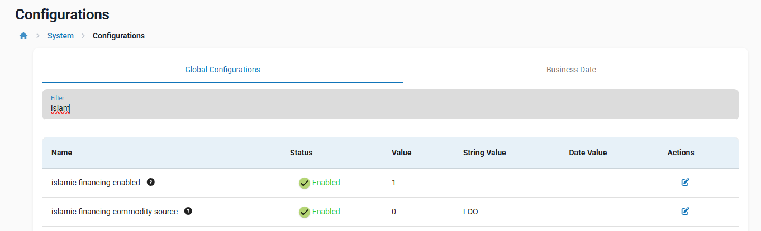

2.2 Automatic Islamic Product Field Control
Introduce a new global configuration controlling whether the system automatically applies UI field restrictions when an Islamic Financing Type is selected.
Configuration
Field | Value
Configuration | Auto Disable Incompatible Islamic Product Fields
Type | Boolean
Default | Yes
Values | Yes / No
Scope | Tenant
Applies To | Islamic Financing product configuration
Purpose
The configuration determines whether the system automatically disables incompatible loan product fields based on the selected Islamic Financing Type.
The configuration controls UI behavior only.
It does not disable the underlying Islamic financing business validations.

Behavior When Enabled
When:
- Islamic Product = Yes; and
- Financing Type = Murabaha
the system shall automatically disable or set applicable incompatible product options according to the Murabaha rules defined in this FRD.
Include:
- Floating/repricing options.(Terms tab → "Is Linked to floating interest rates?" checkbox )

- Profit recalculation. (Settings tab → "Interest Recalculation" section, "Recalculate Profit" checkbox )

- Multiple disbursement where prohibited.(Settings tab → "Financing Tranche Details" → "Enable Multiple Disbursals" checkbox. )


- Top-up where prohibited.
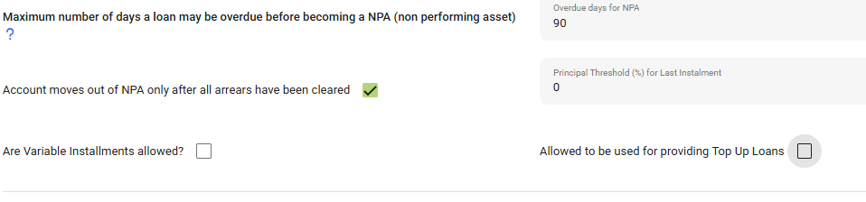
- Account-level pricing override capabilities.
Where an existing field requires a specific value for Murabaha, the system may automatically set the required value and make the field read-only.

Behavior When Disabled
When the configuration is disabled:
- The system shall not automatically disable the applicable product configuration fields.
- Existing product fields shall remain editable according to their standard LMS behavior.
- Murabaha business validations shall continue to apply.
Therefore:
Auto Disable = No ⇒ does not mean Murabaha validations are disabled.

UI Changes
Navigation:
Admin → System → Configurations
Add the new configuration to the existing Islamic Financing configuration area.
No separate configuration screen is required.

3. Murabaha Product Configuration
Enhance the existing Loan Product configuration to define how Profit is established for a Murabaha product and prevent incompatible conventional pricing behavior.

3.1 Required Changes
When: Islamic Product = Yes
And: Financing Type = Murabaha
the system shall introduce the following configuration under the existing Settings section of the Loan Product .
Navigation:
Products → Loan Products → Create / Edit → Settings
Add Profit Input Type within the existing Profit configuration area, adjacent to Profit Method and Profit Calculation Period.

Profit Input Type
Field | Type | Mandatory | Default | Values
Profit Input Type | Dropdown | Yes | Profit Rate (%) | 1- Profit Rate (%)  2- Fixed Profit Amount
Profit Input Type determines how contractual Profit is established before execution of the Murabaha sale.
Once at least one financing account exists under the product, Profit Input Type shall become read-only and cannot be switched between Profit Rate (%) and Fixed Profit Amount.
Murabaha Pricing Lock Point
Field | Type | Mandatory | Default | Values
Murabaha Pricing Lock Point | Dropdown | Yes | Disbursement | 1- Approval 2- Disbursement (3- Sale Executed – future, added by the Murabaha workflow FRD)
● Displayed only when Islamic Product = Yes and Financing Type = Murabaha.
● Defines the financing status from which Cost Price, Profit (Rate or Amount) and Selling Price are locked (Section 4.5).
● Read-only once at least one financing account exists under the product.

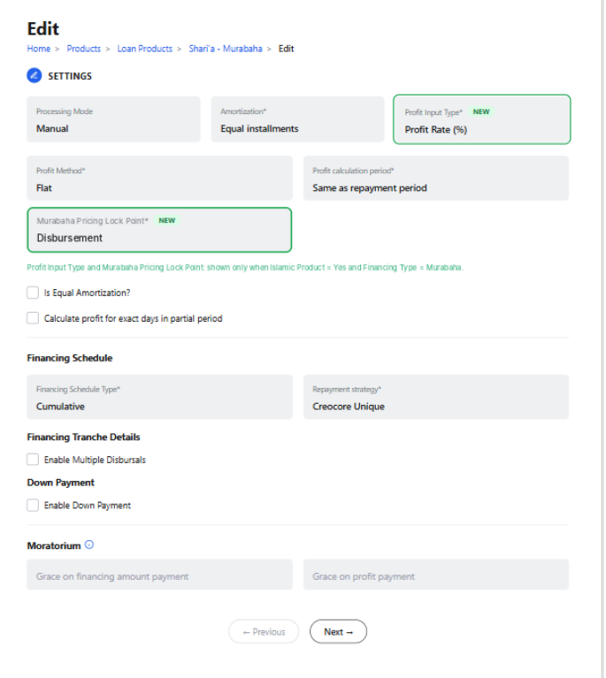
Figure 1: Loan Product Configuration - Settings - Profit Input Type

3.2 Profit Rate Configuration
Selecting Profit Rate (%) shall retain the existing rate-based configuration behavior.

3.3 Fixed Profit Amount Configuration
When Profit Input Type = Fixed Profit Amount:
the system shall replace the existing rate-based pricing section under the Loan Product Terms with a Profit Amount section.
The following rate-based fields shall not be displayed:
- Is Zero Interest/Profit Rate
- Is Linked to Floating Interest/Profit Rates
- Nominal Profit Rate – Minimum
- Nominal Profit Rate – Default
- Nominal Profit Rate – Maximum
- Nominal Profit Rate – Frequency
The system shall instead display the following Profit Amount configuration:
Field | Mandatory | Description
Minimum Profit Amount | Yes | Minimum contractual Profit Amount permitted for a financing created under the product.
Default Profit Amount | Yes | Default Profit Amount populated when creating a financing under the product.
Maximum Profit Amount | Yes | Maximum contractual Profit Amount permitted for a financing created under the product.
The following validation shall apply:
- Minimum Profit Amount ≤ Default Profit Amount ≤ Maximum Profit Amount
- When a financing (Loan Account) is created, the system shall display a mandatory Profit Amount field and populate it with the configured Default Profit Amount.
- The financing-level Profit Amount shall represent the Contractual Profit and shall be used to calculate: Selling Price = Cost Price + Profit Amount
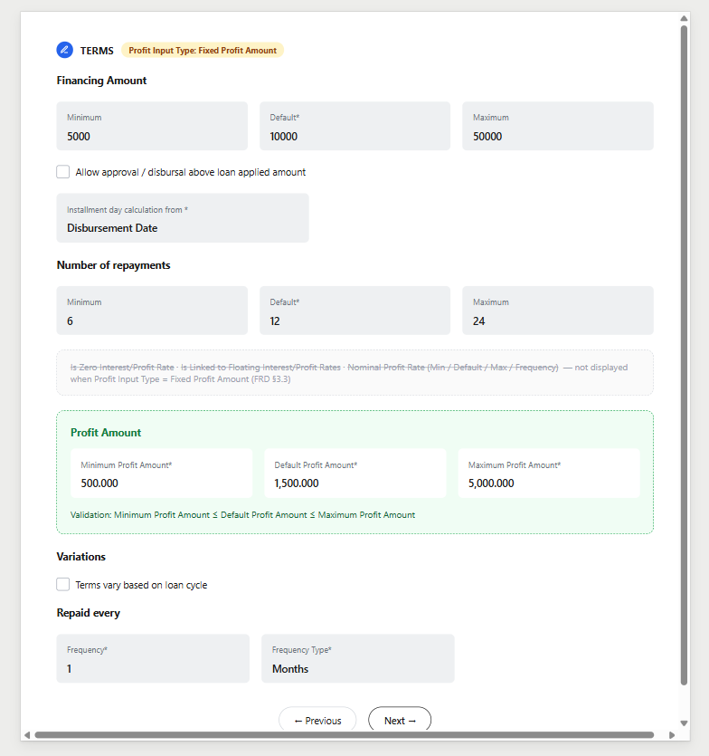
Figure 2: Loan Product Configuration - Terms - Profit Amount Mode

3.4 Murabaha Protected Product Options
Murabaha products shall not be configured with options that can increase or reprice contractual Profit after sale execution.
Applicable controls include:
- Floating/repricing behavior.
- Profit recalculation.
- Prohibited multiple disbursement.
- Prohibited top-up.
- Account-level pricing overrides.

UI Behavior
When Auto Disable Incompatible Islamic Product Fields = Yes, applicable fields shall automatically be:
the system shall automatically apply the required Murabaha configuration to incompatible product fields.
For incompatible Boolean/checkbox fields, the system shall:
- Automatically uncheck the field; and
- Make the field disabled/read-only, preventing the user from enabling it.

Use Cases

Use Case 1 – Existing Incompatible Field is Checked Before Selecting Murabaha
Scenario: :If the user first configures a conventional product field as checked, and subsequently changes the product to Islamic Product = Yes / Murabaha
the system shall:
- Automatically change each incompatible Boolean field from Checked to Unchecked.
- Disable the affected fields.
- Prevent the user from checking the fields while Financing Type remains Murabaha.
This ensures that a previously selected conventional configuration is not retained when it conflicts with Murabaha rules.

Use Case 2 – Murabaha is Selected Before Configuring the Fields
Scenario: The user selects Murabaha before interacting with the applicable Boolean fields.
The system shall:
- Set all incompatible Boolean fields to Unchecked.
- Display the fields as Disabled.
- Prevent the user from changing their values while Financing Type remains Murabaha.

Use Case 3 – Financing Type is Changed from Murabaha
Scenario: The product is currently configured as Murabaha and the applicable Boolean fields are unchecked and disabled. The user subsequently changes the Financing Type from Murabaha to another Financing Type for which these restrictions do not apply.
The system shall:
- Re-enable the applicable fields.
- Keep their current value as Unchecked.
- Not restore values that were selected before Murabaha was configured.
- Allow the user to configure the fields according to the rules of the newly selected Financing Type.
This prevents previously selected values from being silently restored by the system.

Use Case 4 – Auto Disable Configuration is Turned Off
When Auto Disable Incompatible Islamic Product Fields = No, the system shall not automatically uncheck or disable the applicable Boolean fields based solely on the Murabaha selection.
The fields shall remain editable according to their existing behavior.
However, the applicable Murabaha business validations shall continue to apply when saving or activating the product.
Note: The global configuration controls the automatic UI behavior only; it does not disable Murabaha business validations.

Use Case 5 – Fixed Profit Amount Selected
The behavior of the rate-related fields when:
Profit Input Type = Fixed Profit Amount
shall not depend on the Auto Disable Incompatible Islamic Product Fields configuration.
When Fixed Profit Amount is selected, the existing rate-based section containing:
- Is Zero Interest/Profit Rate
- Is Linked to Floating Interest/Profit Rates
- Nominal Profit Rate - Minimum
- Nominal Profit Rate - Default
- Nominal Profit Rate -Maximum
- Frequency
shall not be displayed.
The system shall display the Profit Amount configuration instead:
- Minimum Profit Amount
- Default Profit Amount
- Maximum Profit Amount

4. Murabaha Financing / Loan Account Creation
Apply the Murabaha pricing configuration defined at the Loan Product level when creating an individual financing account and establish the contractual Cost Price, Profit and Selling Price before execution of the Murabaha sale.
The financing-level behavior shall depend on the Profit Input Type configured on the selected Loan Product.

4.1 Cost Price
At financing creation, the existing Cost Price field and behavior shall be reused.
Cost Price represents the acquisition cost used as the basis of the Murabaha transaction.
The Cost Price shall form part of the contractual pricing calculation:
Selling Price = Cost Price + Contractual Profit

4.2 Profit – Profit Rate (%) - No Change
When the selected Loan Product is configured with: Profit Input Type = Profit Rate (%)
the financing account shall continue to use the existing rate-based pricing behavior.
The applicable Profit Rate shall be populated and validated according to the existing Loan Product Minimum / Default / Maximum rate configuration.

4.3 Fixed Profit Amount - New Req
When the selected Loan Product is configured with: Profit Input Type = Fixed Profit Amount
the financing creation screen shall display a new mandatory field:

4.3.1 Profit Amount

Field | Type | Mandatory | Default
Profit Amount | Amount | Yes | Default Profit Amount configured on the Loan Product

The system shall:
- Display Profit Amount under the Terms section.
- Populate the field with the Default Profit Amount configured on the selected Loan Product.
- Allow the user to amend the Profit Amount before the Murabaha sale is executed.
- Validate the entered amount against the Minimum Profit Amount and Maximum Profit Amount configured on the Loan Product.
- Require the Profit Amount to be greater than zero.
The following validation shall apply:
Minimum Profit Amount ≤ Profit Amount ≤ Maximum Profit Amount
The entered Profit Amount shall represent the total Contractual Profit for the financing.

4.3.2 Implied Annual Profit Rate Amount - A Read Only Field
● When Profit Input Type = Fixed Profit Amount, the financing Terms section shall display a read-only Implied Annual Profit Rate, derived from Cost Price, Profit Amount, tenor and repayment schedule using the rate-calculation service defined in Section 5.2. Shown for both Flat and Declining allocation.
● Purpose: let the user check that the entered Profit Amount is reasonable for the Cost Price and tenor (e.g. Cost Price 10,000, Profit Amount 1,500, 12 monthly installments ≈ 26.6% p.a. declining / 15% flat).
● It excludes fees and is not the regulatory APR. APR calculation and disclosure are covered in a later FRD, which will reuse the same rate-calculation service (Section 5.2).
● It shall never be used to recalculate the Contractual Profit; it is refreshed whenever Cost Price, Profit Amount or tenor change before execution.
● It is displayed live while the user enters or changes the Profit Amount (and Cost Price / tenor), so the user sees the equivalent annual rate before submitting.
● At the Pricing Lock Point the value is stored with the contract and shown read-only on the financing account details (General tab) as "Implied Annual Profit Rate (at execution)". It is not recalculated by later servicing actions.

UI Changes for Fixed Profit Amount
When Profit Input Type = Fixed Profit Amount is inherited from the selected Loan Product, the financing Terms section shall adapt to fixed-amount pricing.
The existing Nominal Profit Rate block and fields that are applicable only to rate-based Profit calculation shall not be displayed.
Based on the current Terms screen, the following rate-based fields shall be hidden:
- Nominal Profit Rate
- Frequency, associated with Nominal Profit Rate
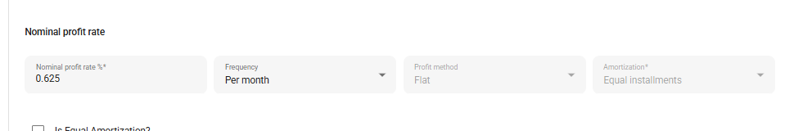
The system shall display Profit Amount instead.
The expected UI behavior is therefore:
Current rate-based behavior
Nominal Profit Rate | Frequency | Profit Method | Amortization
Fixed Profit Amount behavior
Profit Amount | Implied Annual Profit Rate (read-only) | Profit Method | Amortization
- Selling Price is shown read-only next to Cost Price (Financing Amount) at the top of the Terms section.
- Profit Amount validation errors are shown inline under the field (e.g. "Profit Amount must be between 100.000 and 5,000.000", "Profit Amount must be greater than zero");
- the Implied Annual Profit Rate and Selling Price show "—" until the Profit Amount is valid.

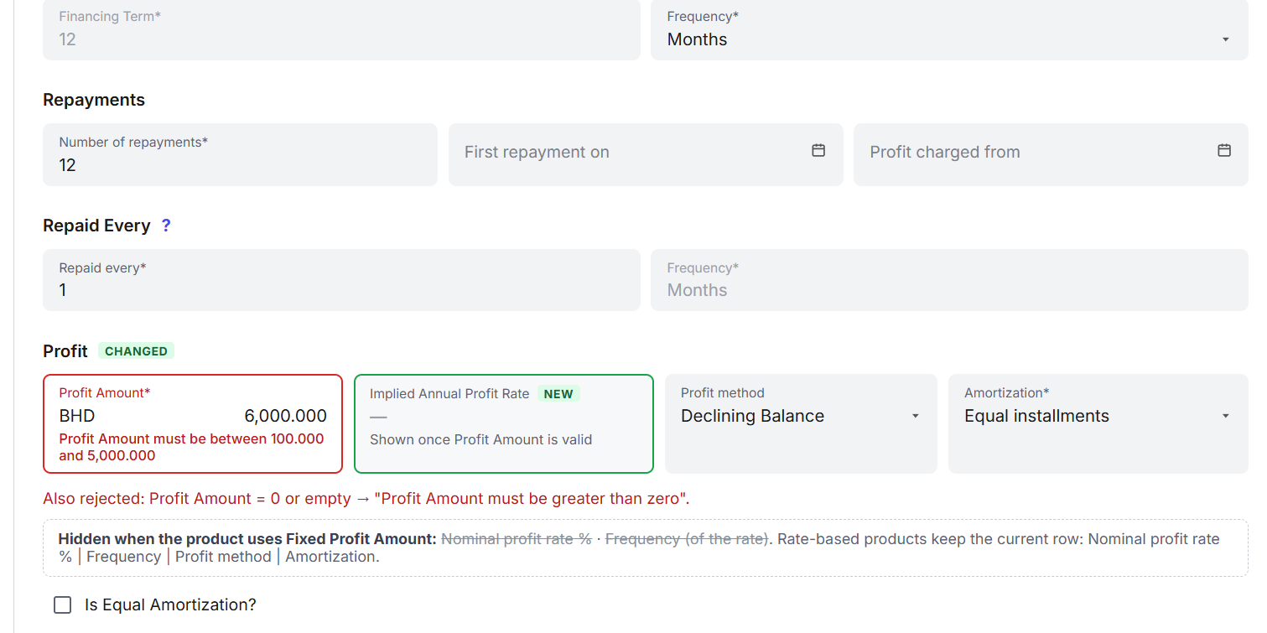

4.4 Selling Price
Selling Price shall always reconcile to: Selling Price = Cost Price + Contractual Profit
- Selling Price shall be system calculated. And shall not be directly editable.(As per the current behavior - Covered in epic: [CBS] Shariah-Compliant Financing - Murabaha)

4.5 Murabaha Execution Event (Pricing Lock Point)
The contractual pricing protection defined in Sections 6 and 8 starts at the Murabaha Execution Event.
The lock point is defined per product by Murabaha Pricing Lock Point (Section 3.1):
● Approval: pricing is locked when the financing is approved. Undo Approval → Modify is not allowed for pricing fields; a pricing change requires Undo Approval followed by Reject / Withdraw, and a new application.
● Disbursement (default): pricing is locked when the financing is disbursed (status Active). Before that, pricing can be corrected through the existing Undo Approval → Modify → Approve.
● Sale Executed (future): pricing is locked when the Sale Executed event is received from the external workflow system. Added by the Murabaha workflow FRD as a new value of the same setting.
Principle: the lock point shall be configured so that pricing is locked no later than the moment the Murabaha sale is concluded with the customer, and never later than disbursement.
Financing status | Cost Price / Profit Amount / Profit Rate | Selling Price
Submitted / Pending Approval | Editable within product Min/Max | System-derived (Cost Price + Profit)
Approved (not yet disbursed) | Editable only through existing Undo Approval → Modify → Approve (maker-checker applies) | System-derived
Active and later | Locked – contractual values | Locked – contractual value
The table above illustrates the default (Disbursement). With Lock Point = Approval, the "Approved" row is also locked.

Native behavior vs. what this FRD adds
Natively, the pricing fields (amount, rate, term) cannot be edited directly after disbursement: Modify Application is only available before approval.
⇒ However, other existing actions can still change the price of an active financing. The lock closes these routes for Murabaha:

Route that can change pricing | Native behavior | Murabaha (this FRD)
Modify Application (direct edit) | Only before approval | No change needed
Undo Disbursal → Undo Approval → Modify | Returns the financing to an editable state | Pricing stays locked (technical correction only)
Reschedule with interest rate adjustment | Changes the rate for the remaining term | Option not available / rejected (6.9)
Reschedule / grace / date change | Recalculates interest on the new dates | Contractual Profit preserved (Section 6)
Interest recalculation, Waive Interest | Can increase or reduce interest | Disabled / blocked (3.4, 6.19)
Top-up, additional disbursement (tranches) | Adds principal and interest | Disabled for executed Murabaha (8.1)
Lock Point = Approval | No native lock at approval (Undo Approval → Modify allowed) | Pricing fields locked from approval
Undo Disbursal shall be treated as a technical correction only: the contractual values remain locked and unchanged. Changing the pricing of an executed Murabaha requires cancelling the financing and creating a new one.
Design rule (to avoid rework): the lock shall be implemented as a single reusable check (e.g. "Is Murabaha Pricing Locked") used by all screens, APIs and schedule-regeneration paths, rather than status checks repeated in each place. A later FRD (Murabaha workflow integration) will extend this check with a Sale Executed event received from the external workflow system, without changing the lock behavior defined in this FRD.
Out of scope of this FRD: Murabaha workflow steps, Sale Executed field, workflow integration and any disbursement gate. These are covered in the Murabaha workflow FRD.

5. Financing Schedule - Fixed Profit Amount Impact

Extend the existing Islamic Financing schedule behavior to support Murabaha products configured with Profit Input Type = Fixed Profit Amount.
The existing Financing Schedule functionality defined under the Islamic Financing Module Epic shall continue to apply. No new repayment schedule screen or separate Murabaha schedule engine shall be introduced.

5.1 Existing Behavior
The existing Islamic Financing Module already provides the following schedule behavior:
- The existing LMS repayment schedule engine is reused.
- Financing Amount represents the existing Principal component.
- Profit represents the existing Interest component.
- Financing Amount equals the Cost Price.
- Selling Price is derived as Cost Price + Profit.
- Existing schedule terminology mapping is applied for Islamic financing.
- Existing repayment and allocation mechanisms are reused.
These behaviors shall remain unchanged.

5.2 Required Change for Fixed Profit Amount
When the selected Loan Product is configured with:
Profit Input Type = Fixed Profit Amount
the schedule shall use the Profit Amount entered at financing creation as the total Profit to be allocated across the repayment schedule.
The system shall not independently calculate a new total Profit from a Profit Rate.
The existing schedule engine and applicable allocation configuration shall be reused to distribute the fixed Profit Amount across the repayment periods.
Profit Allocation Method for Fixed Profit Amount
The existing product field Profit Method shall determine how the fixed Profit Amount is spread across installments:
● Flat: Profit is allocated equally across installments (Profit Amount ÷ number of profit-bearing installments).
● Declining Balance: the system derives the implied periodic profit rate at which the installments repay the Cost Price with total Profit equal to the Profit Amount, and allocates Profit per installment on the outstanding Cost Price (higher Profit in early installments).
In both methods the total allocated Profit shall equal the Profit Amount exactly (Section 5.3).
Implementation note – Implied Profit Rate calculation
● The existing schedule engine calculates Profit from a rate; it does not derive a rate from a given Profit Amount. Deriving the implied periodic rate for Declining Balance is new development: an iterative calculation (standard financial "RATE / IRR" method) that finds the rate at which the installments repay the Cost Price with total Profit equal to the Profit Amount.
● It shall be built as a reusable rate-calculation service. The future APR FRD will reuse the same service (adding fees to the cash flows) without rework.
● For Flat allocation no implied rate is needed to build the schedule (Profit Amount ÷ number of profit-bearing installments).

5.2.1 Implied Profit Rate – Formula, Algorithm and Test Cases
Inputs
● C = Cost Price (Financing Amount)
● P = Profit Amount (Contractual Profit), P > 0
● n = number of profit-bearing installments
● m = installments per year: 12 monthly, 4 quarterly, 52 weekly, 26 every 2 weeks; "repay every k months" → m = 12 ÷ k
● S = Selling Price = C + P
● I = installment = S ÷ n (equal installments). Displayed/posted installment = I rounded to currency precision; residual on the last installment (5.3)
Equation – find the periodic rate r (r > 0) such that:
C = I × [1 − (1 + r)^(−n)] ÷ r (equivalently C = Σ k=1..n I ÷ (1 + r)^k)
Implied Annual Profit Rate (%) = r × m × 100, displayed with 2 decimals. This is a nominal annual rate, the same convention as the Nominal Profit Rate used by the existing schedule engine.
Algorithm (no closed-form solution exists):
● Bisection: low = 0, high = 1 (100% per period).
Repeat: r = (low + high) ÷ 2; PV(r) = I × [1 − (1 + r)^(−n)] ÷ r; if PV(r) > C then low = r else high = r. Stop when |PV(r) − C| < 0.000000001 or after 200 iterations. Calculate with high-precision decimals (e.g. Java BigDecimal, MathContext.DECIMAL128). (Newton-Raphson may be used if it gives the same result.)
● Use full precision (unrounded I and r) in the calculation; round only displayed/posted amounts.
● Spreadsheet equivalent for QA: =RATE(n, −S/n, C) × m.
Using r for Declining Balance allocation (5.2):
● Installments 1 … n−1: Profit_k = round(Outstanding Cost_(k−1) × r); Financing_k = rounded I − Profit_k; Outstanding Cost_k = Outstanding Cost_(k−1) − Financing_k.
● Last installment n: Financing_n = remaining Outstanding Cost; Profit_n = P − Σ Profit_(1…n−1); Installment_n = Financing_n + Profit_n.
● Flat allocation: Profit_k = round(P ÷ n), Financing_k = round(C ÷ n), residuals on the last installment. The Implied Annual Profit Rate is the same for Flat and Declining (same installments); only the split differs.
● Non-equal installments (grace, variable installments): use the actual installment amounts per period, CF_k, with zero for grace periods: C = Σ CF_k ÷ (1 + r)^k.
Test cases (BHD, 3 decimals):
Refer to the attached Implied_Profit_Rate_QA_Test_Cases
Case | C / P / n / frequency | Installment I | r per period | Implied annual rate | Flat equivalent | Installment 1 (Declining): Profit / Financing | Last installment (Declining)
A | 10,000 / 1,500 / 12 / monthly | 958.333 | 2.21854665% | 26.62% | 15.00% | 221.855 / 736.478 | 958.337 (20.798 + 937.539)
B | 5,000 / 600 / 24 / monthly | 233.333 | 0.92722197% | 11.13% | 6.00% | 46.361 / 186.972 | 233.341 (2.143 + 231.198)
C | 20,000 / 3,000 / 8 / quarterly (m = 4) | 2,875.000 | 3.21478614% | 12.86% | 7.50% | 642.957 / 2,232.043 | 2,875.000 (89.545 + 2,785.455)
D | 1,000 / 100 / 7 / monthly | 157.143 | 2.44115203% | 29.29% | 17.14% | 24.412 / 132.731 | 157.142 (3.745 + 153.397)
Every case must also satisfy Section 5.3:
- Σ Profit = P, Σ Financing = C, Σ Installments = S.
  - Case A Flat: Profit 125.000 and Financing 833.333 per installment; last installment 958.337 (125.000 + 833.337).
Cross-check: entering the Implied Annual Profit Rate (unrounded) as the Nominal Profit Rate on a rate-based Declining product with the same terms shall produce total Profit equal to P (difference only from installment rounding).

The generated schedule shall maintain:
Total Financing Amount = Cost Price
Total Profit = Profit Amount
Total Installments = Cost Price + Profit Amount = Selling Price
For example:
Cost Price = BHD 10,000
Profit Amount = BHD 1,500
Selling Price = BHD 11,500
The generated schedule must therefore allocate exactly:
BHD 10,000 Financing Amount + BHD 1,500 Profit
across the applicable installments.

5.3 Rounding and Reconciliation
Existing currency precision and rounding behavior shall continue to apply.
Where distribution of the fixed Profit Amount across installments results in a rounding difference, the schedule shall ensure that the final total Profit reconciles to the financing-level Profit Amount.
The schedule shall not:
- Generate Profit above the entered Profit Amount.
- Leave any portion of the Profit Amount unallocated.
- Recalculate the total Profit based on elapsed time or a Profit Rate.
The final schedule shall satisfy:
Σ Profit = Profit Amount
Σ Financing Amount = Cost Price
Σ Installment Amount = Selling Price

Rounding residual: any rounding difference shall be posted to the last installment so that totals reconcile exactly.
Currency precision shall follow the currency configuration (e.g. BHD = 3 decimal places / fils).

QA;shall include a BHD scenario, e.g. Cost Price BHD 1,000.000, Profit BHD 100.000, 7 installments.

5.4 Profit Rate Products
When:
Profit Input Type = Profit Rate (%)
there shall be no change to the existing Islamic Financing schedule generation behavior.
The existing LMS calculation engine shall continue calculating and allocating Profit according to the current product and financing configuration.

5.5 UI Impact
No new schedule UI is required.
The existing Financing Schedule screen and the Islamic terminology already introduced by the Islamic Financing Module shall continue to be reused.
The only functional difference for Fixed Profit Amount is that the Profit displayed across the schedule originates from the financing-level fixed Profit Amount rather than from a rate-based total Profit calculation.

5.6 Repayment Frequency & Variable Installments
Existing repayment frequency ("repay every N days/weeks/months") and the existing Variable Installments product capability shall be reused for Murabaha, including irregular, seasonal and step-up / step-down patterns. No Murabaha-specific schedule template is introduced in this FRD.
When installment dates or amounts are edited (before execution), the schedule shall still satisfy Section 5.3:
● Σ Profit = Contractual Profit (Profit Amount, or rate-based total for Profit Rate products)
● Σ Financing Amount = Cost Price
● Σ Installment Amount = Selling Price
Edits that break these totals shall be rejected. After execution, installment changes are only possible through the servicing actions in Section 6.

6. Contractual Profit Protection After Murabaha Execution

6.1 Purpose
This section defines the controls required to ensure that, once a Murabaha financing has been executed (see Section 4.5 – Murabaha Execution Event), subsequent servicing activities do not change (increase or reduce) the agreed Contractual Profit or Selling Price.
The existing LMS servicing and repayment schedule capabilities shall continue to be reused. Changes to repayment timing, installment distribution, maturity, or servicing arrangements may be permitted where supported by the existing product, provided that such changes do not reprice the executed Murabaha contract.
⇒ The requirement shall not be implemented as "disable rescheduling for Murabaha".
- When an executed Murabaha schedule is regenerated, the engine shall use the remaining contractual Profit as a fixed amount to redistribute, rather than treating the revised repayment duration as a basis for calculating Profit.
  - This applies whether Profit was established using Profit Rate (%) or Fixed Profit Amount.
- Conventional loan behavior shall remain unchanged.

6.2 Protected Contractual Values
Following execution of the Murabaha sale, the system shall preserve the following contractual values:
● Cost Price
● Contractual Profit
● Selling Price
The contractual relationship shall remain:
Selling Price = Cost Price + Contractual Profit
and, before and after every servicing action:
Profit Paid + Remaining Profit = Contractual Profit
Servicing activities may redistribute the remaining contractual amounts across the revised repayment schedule, but shall not increase or reduce the total Contractual Profit or Selling Price.
Where Profit has already been paid or otherwise settled, it shall not be regenerated as part of a subsequent schedule recalculation.
⇒Any reduction of Profit (e.g. Ibra' / rebate, waiver) shall only occur through an explicit, separately approved transaction defined in a separate FRD. It shall never be a side-effect of schedule recalculation.

6.3 General Servicing Rule
For an executed Murabaha financing, schedule recalculation may change, where permitted:
● Repayment dates
● Maturity date
● Number of remaining installments
● Installment amounts
● Allocation of remaining Cost Price
● Allocation of remaining Contractual Profit
However, schedule recalculation shall not:
● Increase the executed Contractual Profit
● Reduce the executed Contractual Profit (other than through an explicit Ibra' transaction)
● Increase or reduce the Selling Price
● Generate additional Murabaha Profit solely due to elapsed time
● Generate additional Murabaha Profit because repayment is delayed
● Recalculate previously settled Profit
● Compound unpaid Profit into additional Contractual Profit
The remaining contractual obligation shall always reconcile to the executed Selling Price, subject to separately applicable charges that are not part of Murabaha Profit.

6.4 Passage of Time & Accrual Processing
Existing Behavior
Validation of the existing LMS behavior confirmed that passage of time and accrual processing, under the tested configuration, did not increase the originally calculated financing charge.
In the tested scenario, the account became significantly past due and the accrual process continued to recognize the scheduled financing charge. However, cumulative accrued interest did not exceed the original scheduled amount.
Required Behavior
For Murabaha:
● Passage of time shall not generate additional Contractual Profit.
● Accrual processing may recognize the remaining contractual Profit according to the applicable schedule.
● Accrual processing shall not create Profit beyond the executed Contractual Profit.
● No Profit shall accrue after the maturity date or on overdue amounts beyond the contractual schedule.
● Delinquency shall not cause additional Murabaha Profit to accrue.
● Accounting recognition of Profit shall remain separate from any late-payment charges or other applicable charges.
QA Validation
QA shall verify that:
1. The original Contractual Profit is captured before advancing the business date.
2. The business date is advanced beyond one or more installment due dates and beyond the maturity date.
3. Normal accrual processing is executed.
4. The cumulative Profit recognized does not exceed the original Contractual Profit.
5. Selling Price remains unchanged.
Validation result from testing: PASS under the tested configuration. Post-maturity accrual: to be tested.

6.5 Partial Repayment
Existing Behavior
Testing confirmed that a partial repayment did not itself recalculate or increase the original financing charge.
In the tested scenario:
● Original Profit: USD 150.92
● Partial repayment: USD 500.00
● The repayment was allocated between Profit and Cost Price according to the existing repayment behavior.
● Original total Profit remained USD 150.92.
The account was subsequently allowed to become overdue, and the original total Profit remained unchanged.
Required Behavior
For Murabaha:
● Partial repayment shall continue to use the existing repayment allocation behavior.
● Partial repayment shall reduce the outstanding contractual obligation according to the applicable allocation rules.
● Partial repayment shall not recalculate the executed Contractual Profit upward or downward.
● A payment higher than the installment due (prepayment / advance payment) shall be applied to future installments, or held as advance payment, without recalculating Profit on the reduced outstanding balance.
● Subsequent delinquency of the unpaid amount shall not generate additional Contractual Profit.
QA Validation
QA shall verify that:
● Partial repayment does not increase total Contractual Profit.
● Prepayment (payment above the installment due) does not reduce total Contractual Profit.
● Profit already settled is not regenerated.
● Remaining Profit reconciles to the original contractual amount.
● Subsequent delinquency does not increase the contractual Profit.
Validation result from testing: PASS under the tested configuration. Prepayment scenario: to be tested.

6.6 Change Repayment Date
Existing Behavior
Testing identified a gap in the existing LMS behavior.
A loan with an original total Profit of USD 150.92 was rescheduled by changing the repayment date from the existing schedule to a later date, without extending the repayment period or adjusting the interest rate.
Following the date change, the system recalculated the schedule and increased total interest to USD 276.29.
This represents an increase of: USD 276.29 − USD 150.92 = USD 125.37
Required Behavior
For executed Murabaha:
● Changing a repayment date shall not increase Contractual Profit.
● Moving a repayment date earlier shall not reduce Contractual Profit.
● The additional elapsed period shall not be used to generate additional Murabaha Profit.
● The revised schedule may redistribute the remaining contractual amounts.
● The revised schedule shall continue to reconcile to the original Selling Price.
● Existing conventional loan behavior shall remain unchanged.
QA Validation
QA shall reproduce the scenario using an executed Murabaha financing and verify:
● Contractual Profit before rescheduling.
● Contractual Profit after changing the repayment date.
● Selling Price before and after the change.
● Profit already paid and remaining Profit.
Expected result: Contractual Profit and Selling Price remain unchanged.
Validation result from current LMS testing: GAP IDENTIFIED.

6.7 Mid-term Grace Period
Existing Behavior
Testing identified a gap in the existing LMS behavior.
A loan with original Profit of USD 127.35 was rescheduled using:
● Principal Grace Periods: 2
● Interest/Profit Grace Periods: 1
● No repayment-date change
● No repayment-period extension
● No interest-rate adjustment
Following the grace-period application, total calculated interest increased to USD 155.50.
This represents an increase of: USD 155.50 − USD 127.35 = USD 28.15
Required Behavior
For executed Murabaha:
● Grace periods may defer repayment of Cost Price and/or Profit where permitted.
● Grace periods shall not increase Contractual Profit.
● Deferred Profit shall remain part of the original contractual Profit.
● The revised schedule may redistribute the remaining contractual amounts.
● Selling Price shall remain unchanged.
QA Validation
QA shall verify that applying:
● Principal grace only
● Profit grace only
● Combined principal and Profit grace
does not increase Contractual Profit or Selling Price.
Validation result from current LMS testing: GAP IDENTIFIED.
Grace screens : the existing grace / moratorium and Mid-term Grace screens are reused; no Murabaha-specific grace screen is introduced. Where a schedule preview is shown, the revised schedule shall preserve the contractual totals. If schedule regeneration caused by grace would increase or decrease Contractual Profit or Selling Price, the action shall be rejected.

6.8 Extend or Shorten Repayment Period
Required Behavior
Where the existing LMS capability allows the repayment period or number of installments to be extended or reduced:
● The maturity date may be extended or brought forward.
● The number and amount of installments may change.
● Remaining Cost Price and Contractual Profit may be redistributed.
● Total Contractual Profit shall not increase or decrease.
● Selling Price shall not increase or decrease.
● Additional elapsed time shall not generate additional Murabaha Profit.
● A shorter remaining tenor shall not reduce Profit; any reduction requires an explicit Ibra' transaction.
QA Validation
QA shall capture the original Contractual Profit and Selling Price, extend (and separately shorten) the repayment period, and verify that:
Profit after change = original remaining contractual Profit and Selling Price after change = original Selling Price
Include a long extension (30, 60, 90+ additional days crossing the original maturity).
Status: To be tested.

6.9 Interest / Profit Rate Adjustment
Required Behavior
For an executed Murabaha, the existing capability to adjust the interest/profit rate for the remainder of the financing shall not result in repricing of the executed Murabaha contract or an increase or decrease in Contractual Profit or Selling Price.
Where the existing adjustment capability cannot preserve the executed contractual pricing, the action shall not be permitted for the Murabaha financing (option hidden in the reschedule screen and rejected by the API).
The existing conventional loan behavior shall remain unchanged.
QA Validation
QA shall verify that an executed Murabaha cannot be repriced through a rate adjustment that changes the contractual Profit.
Status: To be validated.

Summary for loan reschedule:
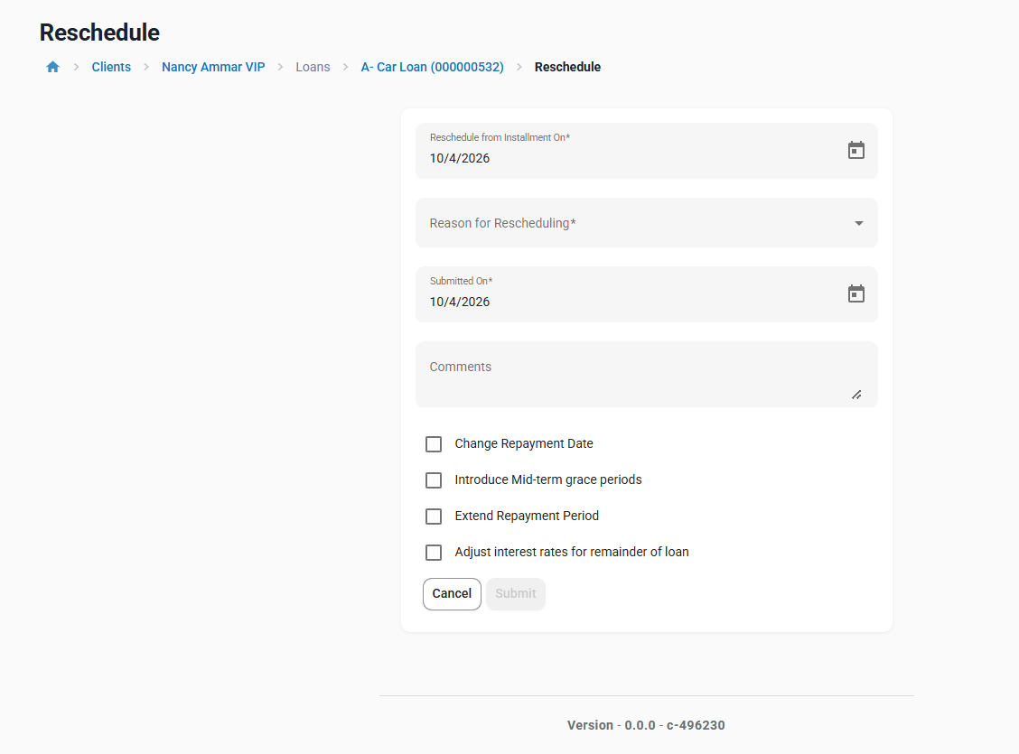

Option on your screen | Murabaha (executed)
Change Repayment Date | Keep, with the profit protection from 6.6
Introduce Mid-term grace periods | Keep, with the protection from 6.7
Extend Repayment Period | Keep, with the protection from 6.8
Adjust interest rates for remainder of loan | Hide (6.9)

6.10 Combined Rescheduling Actions
The contractual protection shall also apply where multiple servicing actions are performed together, including combinations such as:
● Change Repayment Date + Extend Repayment Period
● Grace Period + Extend Repayment Period
● Change Repayment Date + Grace Period
● Other supported combinations that regenerate the repayment schedule
The combination of servicing actions shall not provide a route for changing Contractual Profit or Selling Price when an individual action is restricted.
QA Validation
QA shall execute the supported combinations and verify the same contractual invariants defined in Section 6.2.

6.11 Rescheduling After Partial Repayment
Rescheduling shall operate on the remaining contractual amounts.
Where part of the original Contractual Profit has already been paid:
● Paid Profit shall remain settled.
● It shall not be regenerated in the revised schedule.
● Only the remaining contractual Profit shall be available for redistribution.
● Total Profit paid plus remaining Profit shall equal the executed Contractual Profit.
Example: Contractual Profit = 150; Profit already paid = 30 ⇒ the revised schedule shall allocate exactly 120 of remaining Profit (not a new 150 and not a time-based amount).
QA Validation
QA shall:
1. Execute a partial repayment.
2. Capture Profit already paid and remaining Profit.
3. Reschedule the financing.
4. Verify that previously paid Profit is not recreated.
5. Verify that total Profit equals the original contractual amount.

6.12 Late Payment & Delinquency
Late payment may result in overdue amounts and applicable charges in accordance with the product configuration.
However, for Murabaha:
● Delinquency shall not increase Contractual Profit.
● Additional overdue days shall not generate additional Murabaha Profit.
● Existing accrual processing shall remain subject to the contractual Profit ceiling.
● Any applicable late-payment charge, penalty, or other non-Profit amount shall remain separately identifiable and shall not be added to Contractual Profit or Selling Price (treatment of late-payment charges, e.g. routing to charity, is defined in a separate FRD).
QA Validation
QA shall test:
● One-day overdue
● Extended delinquency
● Overdue beyond the maturity date
● Partial repayment followed by delinquency
● Delinquency after rescheduling
and verify that Contractual Profit and Selling Price remain unchanged.

6.13 Early / Full Settlement
Where early or full settlement is supported:
● Settlement shall not generate additional Contractual Profit.
● The outstanding contractual amounts shall be determined from the executed Murabaha contract.
● Until the Ibra' / early-settlement FRD is delivered, the settlement (payoff) amount shall be the outstanding Selling Price, i.e. outstanding Cost Price + full remaining contractual Profit.
● The existing pre-closure / foreclosure calculation that limits interest to the settlement date shall not be applied to executed Murabaha, as it would implicitly reduce Contractual Profit.
● Any applicable reduction, waiver, or Ibra treatment shall follow the separately defined Ibra rules where in scope.
● Settlement processing shall not reprice the original Murabaha contract.

6.14 Reversal / Correction
Where repayment or servicing transactions are reversed or corrected:
● The contractual Profit shall remain based on the executed Murabaha pricing.
● A reversal shall not create duplicate Profit.
● Previously recognized Profit shall not be compounded or regenerated beyond the contractual amount.
● Reversal of a repayment, or undo of a reschedule, shall restore the previous schedule and Profit allocation exactly.
● The account shall reconcile to the appropriate contractual position following the correction.

6.15 Other Date / Tenor Changes
Any other existing servicing operation that changes:
● Repayment dates
● Maturity
● Repayment frequency
● Number of installments
● Grace periods
● Remaining tenor
● Business-day / holiday adjustments and first installment date
● Or otherwise regenerates the repayment schedule

Where these changes come from in the LMS
● Working days and holidays – Admin → Organization → Working Days (rule for repayments falling on non-working days) and Admin → Organization → Holidays. A holiday defined after disbursement is applied to existing financings by the scheduler job "Apply Holidays To Loans". The moved due dates shall not change Contractual Profit.
● First repayment date – "First repayment on" / "Profit charged from" on the financing Terms, and the schedule rebuilt at Disburse when the actual disbursement date differs from the expected one. Fixed Profit Amount: Profit Amount unchanged. Profit Rate: Profit is calculated with the actual first period at the Pricing Lock Point and is locked from then on.
● Due-date adjustments and other permitted schedule-date changes – Reschedule (Change Repayment Date, Mid-term grace, Extend Repayment Period), see Sections 6.6–6.8.
● Existing date-adjustment functionality is reused; no new Murabaha-specific date screen is introduced.

shall be subject to the same contractual Profit protection defined in this section.
This prevents the requirement from being limited only to the specific rescheduling options currently identified and ensures that future or existing schedule-regeneration paths cannot inadvertently change executed Murabaha Profit.
If any schedule regeneration would break the invariant in Section 6.2, the action shall be rejected.

6.16 Accounting & Accrual Impact
The contractual Profit protection applies to the customer's contractual obligation, not to the timing of accounting recognition.
The system may continue to recognize the contractual Profit through the existing applicable accrual process. However:
● Accounting accruals shall not create additional contractual Profit.
● Cumulative Profit recognition over the life of the financing shall equal the executed Contractual Profit (less any explicit Ibra').
● Accrual timing may change following a permitted schedule change, but the contractual Profit ceiling shall remain unchanged.
● Any late-payment charge or other separately applicable amount shall remain distinct from Murabaha Profit.

6.17 QA Validation Matrix
For every scenario capture before and after: Cost Price, Contractual Profit, Selling Price, Profit Paid, Remaining Profit, Maturity Date, Number of Installments. Every scenario must satisfy the Section 6.2 invariant and leave conventional products unchanged.
# | Scenario | Ref | Current Test Result | Murabaha Expected Result
1 | Passage of time / accrual | 6.4 | PASS | No increase in Contractual Profit
2 | Accrual past maturity | 6.4 | To be tested | No Profit after maturity
3 | Partial repayment | 6.5 | PASS | No increase in Contractual Profit
4 | Prepayment (above installment due) | 6.5 | To be tested | No decrease in Contractual Profit
5 | Partial repayment + delinquency | 6.5 / 6.12 | PASS | No increase in Contractual Profit
6 | Change Repayment Date | 6.6 | GAP | Preserve Contractual Profit
7 | Mid-term Grace Period | 6.7 | GAP | Preserve Contractual Profit
8 | Extend Repayment Period | 6.8 | To be tested | Preserve Contractual Profit
9 | Shorten Repayment Period / earlier dates | 6.8 | To be tested | Profit not reduced
10 | Profit Rate Adjustment | 6.9 | To be tested | No contractual repricing
11 | Combined rescheduling | 6.10 | To be tested | Preserve Contractual Profit
12 | Rescheduling after partial repayment | 6.11 | To be tested | Do not regenerate paid Profit
13 | Late payment / extended delinquency | 6.12 | Tested | No additional Contractual Profit
14 | Early settlement | 6.13 | To be tested | No additional Contractual Profit ; payoff = outstanding Selling Price
15 | Reversal / correction | 6.14 | To be tested | No duplicate/recreated Profit ; previous schedule restored
16 | Other schedule regeneration | 6.15 | To be tested | Same contractual ceiling
17 | Fixed Profit Amount schedule (Flat & Declining, BHD 3 decimals) | 5.2 / 5.3 | To be tested | Σ Profit = Profit Amount; residual on last installment
18 | Conventional regression (repeat 6–8 on conventional loan) | — | To be tested | Existing behavior unchanged

6.18 Core Acceptance Principle
For every servicing action that regenerates or modifies the Murabaha repayment schedule:
The servicing action may change when and how the remaining contractual amounts are collected, but it shall not change how much Contractual Profit was agreed at execution.
i.e. Profit Paid + Remaining Profit = Contractual Profit at all times; neither more nor less.

6.19 Profit Waiver (Waive Interest) on Executed Murabaha
The existing "Waive Interest" action reduces outstanding interest and would silently reduce Contractual Profit.
● For executed Murabaha, the Waive Interest/Profit action shall be unavailable in the UI and rejected by the API.
- Already done by the IBRA’ EPic
● Any reduction of Profit shall be introduced only through the Ibra' FRD as an explicit, approved transaction.
● Waiver of charges (fees, late-payment charges) is not affected and continues to use existing behavior.
QA: attempt Waive Interest on an executed Murabaha → action not available / API rejected; Contractual Profit unchanged.

6.20 Write-off of Murabaha Financing
● Existing write-off functionality shall be reused.
● Write-off shall not change the recorded Contractual Profit, Profit Paid or Selling Price. The unpaid Cost Price and unpaid Profit shall be shown as written off.
● Accounting treatment of the written-off amounts (incl. any suspended/unearned profit) is defined in the Murabaha accounting FRD.

6.21 Top-up and Payoff Quote – Native Behavior Not Applied
● The native top-up closes the old loan by including its payoff (with interest up to the payoff date) in the new loan principal. For Murabaha this would turn remaining Profit into Cost Price of the new contract and reduce the old Profit. Top-up is therefore disabled for executed Murabaha (Section 8.1); the compliant top-up flow is defined in a separate FRD.
● Payoff / settlement quotes (screen and API) for executed Murabaha shall use the rule in Section 6.13 (outstanding Selling Price).

7. Additional Controls and Impacts
This section specifies the scope items listed in Section 1.4 that were not yet detailed.

7.1 Permissions and Maker-Checker
● Existing permissions and maker-checker settings for loan reschedule, grace, repayment reversal and loan modification shall apply unchanged to Murabaha.
● Changing the global configuration "Auto Disable Incompatible Islamic Product Fields" and changing Profit Input Type / Profit Amount limits on a product shall be subject to maker-checker where enabled.

7.2 Audit Requirements
● For every servicing action on an executed Murabaha, the audit trail shall record: user, checker, timestamp, action, and before/after values of Contractual Profit, Profit Paid, Remaining Profit and Selling Price.

7.3 API Impact
● Loan Product API: new fields profitInputType (RATE | FIXED_AMOUNT), minProfitAmount, defaultProfitAmount, maxProfitAmount.
● Loan Product API: new field pricingLockPoint (APPROVAL | DISBURSEMENT); default DISBURSEMENT.
● Loan Account API (create / modify / template / schedule calculation): new field profitAmount; response includes contractualProfit, profitPaid, remainingProfit, sellingPrice, impliedAnnualProfitRate.
● Validation errors for: amount outside Min/Max, Profit Amount ≤ 0, Profit Input Type change with existing accounts, post-execution pricing change, invariant breach.
● Backward compatible: when profitInputType is not supplied it defaults to RATE; existing payloads keep working.

7.4 Accounting and Reporting Impact
● No new GL model under this FRD; existing Islamic financing accounting mappings are reused.
● Profit accrual shall follow the current (possibly rescheduled) schedule; total Profit accrued over the life of the financing shall equal Contractual Profit.
● Loan details and portfolio reports shall show Contractual Profit, Profit Paid and Remaining Profit for Murabaha financings.
● Financing account details shall also show the stored Implied Annual Profit Rate (at execution) and the product's Pricing Lock Point (read-only).

7.5 Backward Compatibility and Existing Murabaha Financings
● Existing Murabaha products default to Profit Input Type = Profit Rate (%); no reconfiguration is required.
● Conventional products and loans shall remain unchanged.

8. BEDE Functional Requirements Coverage
This section lists the BEDE requirements addressed by this FRD. "Native" = existing Fineract/LMS capability reused through configuration. Requirements not listed (e.g. FR-02, FR-05/06, FR-10, FR-12, FR-21, integrations and non-functional requirements) are covered in separate FRDs. APR (roadmap #25) is covered in a later FRD reusing the rate-calculation service of Section 5.2.
BEDE Req | Requirement (short) | Coverage | Where | Notes / remaining
FR-01 | Configurable Sharia products (term, amount, profit, fees, frequency, grace) | Covered here + Native | 3, 4 | Profit Input Type, Profit Amount Min/Default/Max added; other parameters native. Eligibility tags → separate FRD.
FR-03 | Repayment templates: irregular, bullet, step-up/down, seasonal | Native + Covered here | 5.6 | Native frequency + Variable Installments; this FRD keeps totals reconciled. Reusable saved templates not included.
FR-04 | Allocation order, day-count, rounding, weekend/holiday | Native + Covered here | 5.3, 6.15 | Native configuration; this FRD ensures date/holiday shifts never change Profit.
FR-07 | Murabaha contract model: cost, profit, selling price | Covered here | 4, 5 | Commodity purchase/sale steps → workflow FRD.
FR-09 | Profit recognition; no compounding; late charges to charity | Partly here | 6.3, 6.12, 6.16 | No compounding and late charges kept separate from Profit covered here. Charity routing & recognition rules → separate FRD (rule: may not add to or reduce Contractual Profit).
FR-11 | Accounting sub-ledger | Partly here | 6.16, 8.8 | Total recognized Profit = Contractual Profit. GL model → separate FRD (rule: 90+ DPD suspension stops recognition only, never reduces Contractual Profit).
FR-18 | Early settlement options + in-app quote | Partly here | 6.13, 6.21 | Interim rule: payoff = outstanding Selling Price. Settlement options → Ibra' / settlement FRD.
FR-19 | Partial payment with FR-18 charging options + schedule recalculation | Partly here | 6.5, 6.11 | Profit unchanged on partial payment/prepayment; remaining amounts redistributed. Charging options → Ibra' / settlement FRD.
FR-20 | Top-up (new or consolidated contract) | Partly here | 8.1, 6.21 | Native top-up disabled for Murabaha; compliant flow → separate FRD.
FR-22 | Deferment with profit treatment | Covered here (profit) / separate (limits) | 6.7, 6.8 | Deferment never changes Profit. Limits per product → separate FRD.
FR-23 | Restructuring/rescheduling with maker-checker & audit | Covered here + Native | 6, 8.4–8.6 | —
FR-24 | Write-off, fee waiver, refund, overpayment | Native + Covered here | 6.5, 6.14, 6.19, 6.20 | Native actions reused; Waive Interest blocked on Murabaha; write-off keeps Contractual Profit. Partial write-off: verify (roadmap #28).
FR-25 | Statements, schedules, settlement quotes | Partly here | 6.13, 6.21 | Schedule native; payoff quote uses Murabaha rule. Customer statements → separate FRD.
FR-26 / FR-27 | Delinquency rules and stages | Native (partly) + Covered here | 6.12 | Native DPD buckets/ranges reused; delinquency never adds Profit. Amount/missed-installment thresholds, pre-due stage → separate FRD.
FR-32 | Maker-checker on configuration & financial adjustments | Native | 8.5 | Enable maker-checker for the new configurations and Murabaha servicing actions.
FR-33 | Immutable audit trail, exportable | Native (mostly) + Covered here | 8.6 | Native command audit for all write actions; this FRD adds before/after Profit values and rejection logging. Read-action logging not included.
INT-STD-1 | API specifications | Covered here | 8.7 | New fields backward compatible.
M-04 | Original contract terms preserved | Partly here | 8.9 | Contractual Profit captured for active Murabaha at go-live; data migration → separate FRD.

